

Submitted by: Muqadas nawazz
Submitted to: Mam Nayab Khalid
Sap id: 73671

Task 01:

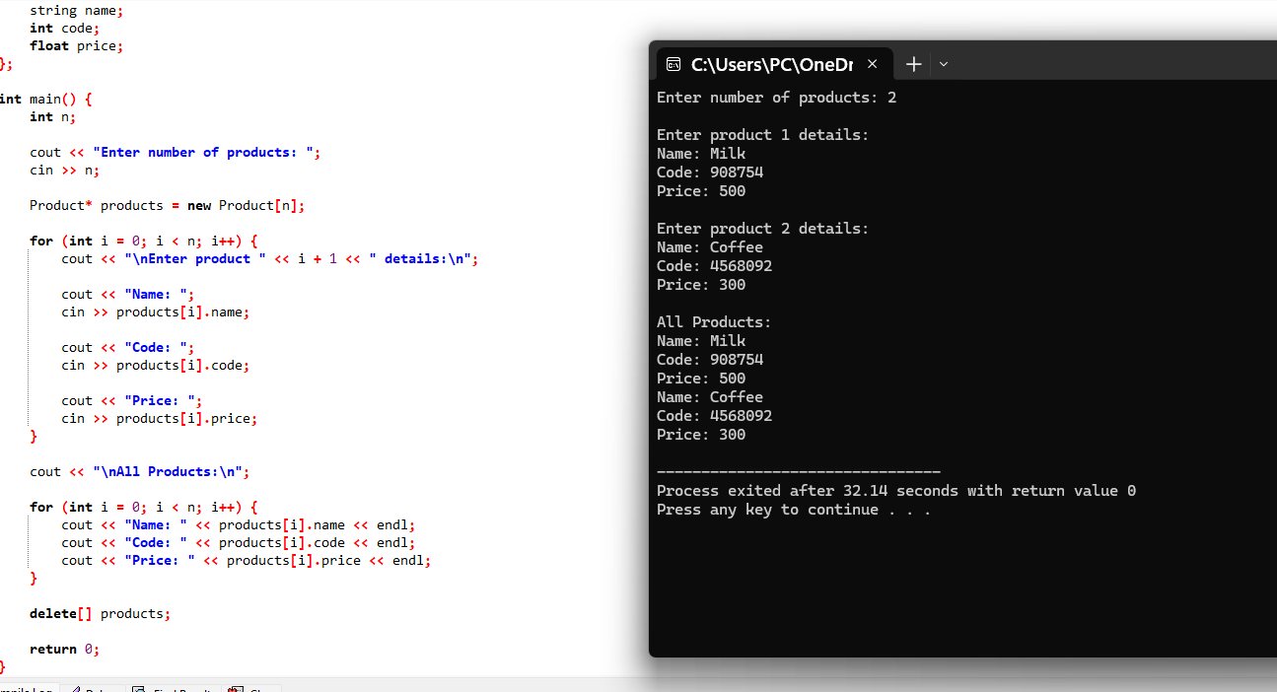
Task 2:

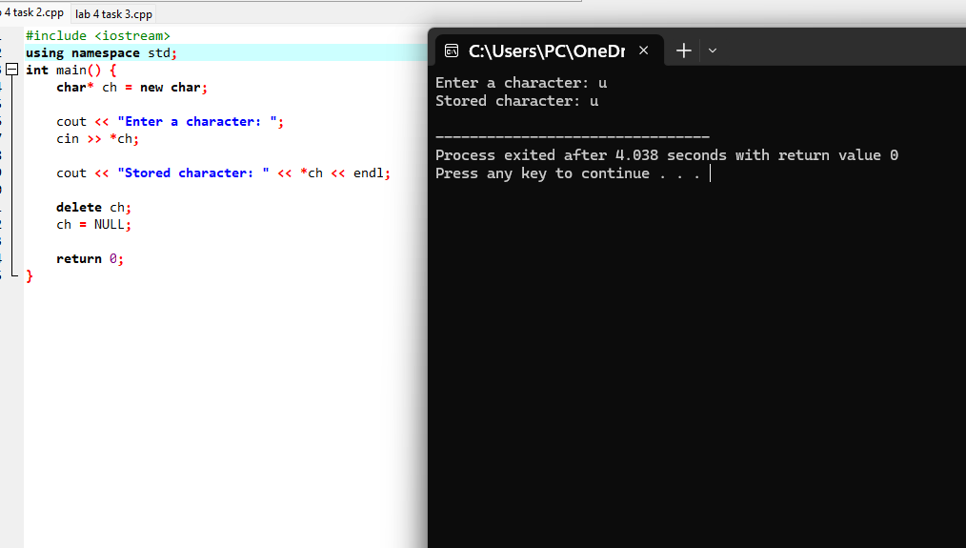
Task 3:



